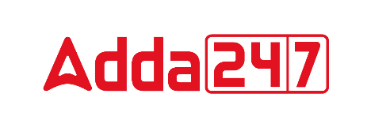

**VOCABULARY**

**1. Altruist (noun)**

**Meaning**; A person showing regard for others



**Synonyms**: benevolent, humanitarian

**Antonyms**: selfish, cruel

**2. Incongruous (adjective)**

**Meaning**; Not similar or congruent; not matching



**Synonyms**: incoherent, contradictory

**Antonyms**: compatible, consistent

**3. Embrace (verb)**

**Meaning**; To accept; to undergo; to submit to.



**Synonyms**: adopt, accept

**Antonyms**: exclude, reject

**4. Obstreperous (adjective)**

**Meaning**; Stubbornly defiant



**Synonyms**: blusterous, boisterous

**Antonyms**: silent, compliant

**5. Exegesis (noun)**

**Meaning**; An exposition or explanation of a text

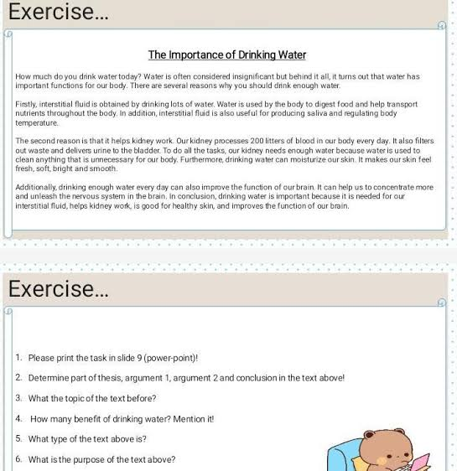

**Synonyms**: elucidation, illustration

**Antonyms**: straight, brief

**6. Scalding (adjective)**

**Meaning**; An instance of scalding: a burn.



**Synonyms**: blazing

**Antonyms**: cold

**7. Buttress (verb)**

**Meaning**; Anything that supports or strengthens.



**Synonyms**: reinforce, strenghten

**Antonyms**: weaken, reduce